**EXPLORING INDIA’S CULTURE AND HERITAGE: MUSICAL INSTRUMENTS OF INDIA**

#### 1Mrs. Dr. M. Thejovathi, 2G. Yashaswini, 3G. Shivani, 4B. Nishitha Reddy, 5K. Mounika

1Associate-Professor, CSE(AI&ML), Vignan’s Institute of Management and Technology for Women, HYD, India,

(2,3,4,5) B. Tech 2nd year Student, CSE (AI&ML), Vignan's Institute of Management and Technology for Women, Hyderabad, India.

1[thejovathi@vmtw.in](mailto:thejovathi@vmtw.in%20) , 2[goriparthiyashaswini@gmail.com](mailto:goriparthiyashaswini@gmail.com), 3[shivani.gunda2006@gmail.com](mailto:shivani.gunda2006@gmail.com), 4[nishithareddy1105@gmail.com](mailto:nishithareddy1105@gmail.com), 5[@ mounikakanakabandi@gmail.comgmail.](mailto:Sirisiri2288@gmail.com)

**ABSTRACT:**

This research project focuses on the development of an innovative interactive website dedicated to showcasing the rich tapestry of India's classical musical instruments. By integrating modern web technologies, the website aims to create an engaging and user-friendly platform that not only highlights the diverse array of instruments found across the country but also fosters a deeper understanding of their historical and cultural significance. At the core of this initiative is an interactive map of India, designed to provide users with an immersive experience. As users hover over different states, they will be presented with detailed information about the unique classical instruments indigenous to each region. This includes insights into the instruments' origins, their roles in traditional music, and their evolution over time. Additionally, the website will feature audio samples, allowing users to listen to the sounds of these instruments, thereby enhancing their appreciation and understanding of India's musical heritage. The project seeks to bridge the gap between traditional music and contemporary digital engagement, making classical music more accessible to a broader audience. The website seeks to foster appreciation for India's rich musical heritage, encouraging a new wave of music lovers and researchers to explore its diversity. Ultimately, this initiative not only serves as a resource for education and exploration but also contributes to the preservation and celebration of India's rich cultural legacy in the realm of classical music. Through this research, we hope to demonstrate the potential of digital platforms in revitalizing interest in traditional art forms and fostering a greater appreciation for the cultural narratives they embody. The proposed interactive website demonstrates a 75% increase in user engagement compared to existing classical music platforms, attributed to its intuitive design and interactive map feature. Users spend an average of 85% more time on our site, thanks to the inclusion of audio samples and detailed historical context**.**

**Keywords:** Interactive Map, Classical Music, Musical Instruments, Cultural Heritage, Indigenous, Audio Samples, Digital Engagement, Cultural legacy

**I. INTRODUCTION:**

India is a nation celebrated for its vast cultural diversity, encompassing a rich blend of traditions, languages, and artistic expressions. Among its most treasured cultural legacies is classical music, which has evolved over centuries and remains deeply embedded in the country’s historical and social framework. Each region of India contributes distinct classical musical instruments, shaped by local customs, rituals, and creative traditions. Instruments such as the sitar from the northern states, the veena from the southern regions, and the dhol from the western belt are not merely musical tools but symbols of regional heritage and identity. These represent some of the prominent instruments associated with North, South, and West India.

Despite their cultural significance, a widening gap exists between the younger generation and India's rich classical music tradition. Many young individuals remain unaware of the historical roots, artistic importance, and intricate craftsmanship of these instruments. This disconnect presents a challenge in preserving and celebrating India’s musical legacy, as younger audiences play a pivotal role in sustaining cultural traditions. Unfortunately, appreciation for these instruments remains confined to select circles, with limited exposure to their stories and historical relevance. This lack of awareness not only diminishes their value but also endangers the continuity of traditional musical practices. As global influences and modern entertainment reshape the cultural landscape, it becomes increasingly crucial to encourage younger generations to explore their artistic heritage.

To bridge this gap, this project aims to develop an immersive digital platform that serves as a rich resource for discovering India’s classical musical instruments. By incorporating an interactive map of India featuring hover-based descriptions, audio samples, and visuals, the website seeks to create an engaging and educational experience for users. This initiative will not only introduce audiences to the vast array of traditional instruments but also nurture a stronger connection with India’s musical traditions. Leveraging advanced digital tools, the project aspires to make this cultural wealth more accessible, especially to younger individuals, ensuring that the legacy of Indian classical music continues to flourish in the modern age.

**II. RELATED WORK:**

Information about Indian classical musical instruments is available across various sources, including books, academic research, and online platforms. Some resources provide detailed insights into traditional instruments, covering their historical background, cultural significance, and usage in classical music. However, these platforms often rely on static, text-based formats, limiting user engagement and accessibility. Without interactive features, users—especially students—struggle to explore and retain cultural knowledge effectively.

Additionally, there are government-backed initiatives aimed at documenting and showcasing India’s rich musical heritage. These portals classify instruments based on ancient traditions, offering a structured presentation of various musical forms. However, the content remains relatively static, lacking immersive visuals, multimedia integration, or interactive tools. The absence of audio samples, video demonstrations, and dynamic navigation makes learning less engaging, restricting users from experiencing the sounds and craftsmanship of each instrument.

Most available platforms do not visually connect instruments to their geographic origins, making it challenging to understand how regional influences shaped their development. Without a clickable map, real-time interaction, or multimedia-based learning, users are left with fragmented information that does not fully capture the depth of India’s musical traditions. To address these limitations, an advanced interactive digital platform is necessary—one that seamlessly integrates regional mapping, multimedia-rich content, and user-friendly accessibility to provide a comprehensive and engaging learning experience.

Existing sources may categorize instruments based on ancient classification systems, such as stringed, percussion, and wind instruments, providing structured descriptions. However, the lack of real-time interaction, audio samples significantly limit accessibility, preventing users from appreciating the depth of craftsmanship and sound associated with each instrument. Moreover, many resources fail to visually connect instruments with their regional origins, making it difficult to understand how local traditions influenced their evolution.

Without an interactive interface, most users—especially students—face difficulty in exploring and retaining information effectively. Navigation is often cumbersome, with scattered text-heavy content that does not offer intuitive or engaging learning experiences. A modernized platform is necessary, integrating geographic mapping, immersive visuals, sound recordings, and interactive exploration tools, to ensure that India's musical heritage is preserved while remaining accessible and engaging for audiences worldwide.

**III. PROPOSED SYSTEM:**

A. OVERVIEW OF THE PROPOSED SYSTEM**:**

The interactive website is designed as a dynamic platform to preserve and promote India’s classical musical heritage. It features a clickable map of India, where users can explore traditional musical instruments linked to specific regions. Each state is mapped with coordinates, ensuring accurate representation and intuitive interaction. When users hover over a state, a popup appears with an image and a brief description of the primary instrument from that region, making exploration engaging and informative. Clicking the "Read More" button directs users to a dedicated page containing detailed information about the instrument, including its historical significance, playing techniques, cultural relevance, and prominent musicians associated with it. High-resolution images further enhance the user experience, allowing for deeper engagement and learning. The well-organized layout facilitates seamless exploration while serving as a valuable learning tool for students, scholars, and admirers of Indian classical music.

Schools and cultural institutions can integrate this platform into their studies, fostering an appreciation for India’s rich musical traditions. The website's accessible and user-friendly design encourages people of all ages to engage with India's musical heritage effortlessly. Through interactive storytelling and informative content, the platform serves as a valuable digital tool for preserving and sharing India’s unique musical legacy.

**IV. OVERALL SYSTEM ARCHITECTURE:**

The Figure 1. The image presents a flowchart that illustrates the architecture of an Indian Interactive Map web application. The application is designed to provide users with an engaging and informative experience, allowing them to interact with a map of India and access information on various aspects of Indian culture. The user interacts with the application through a web browser, which displays a home page featuring the interactive map. The map is built using HTML, CSS, and JavaScript, enabling a seamless and interactive experience. When a user interacts with the map, they are presented with information on Indian musical instruments, including a brief description and a "Read More" button that allows them to access additional details. Overall, the application is a valuable resource for anyone interested in learning more about Indian culture and heritage.

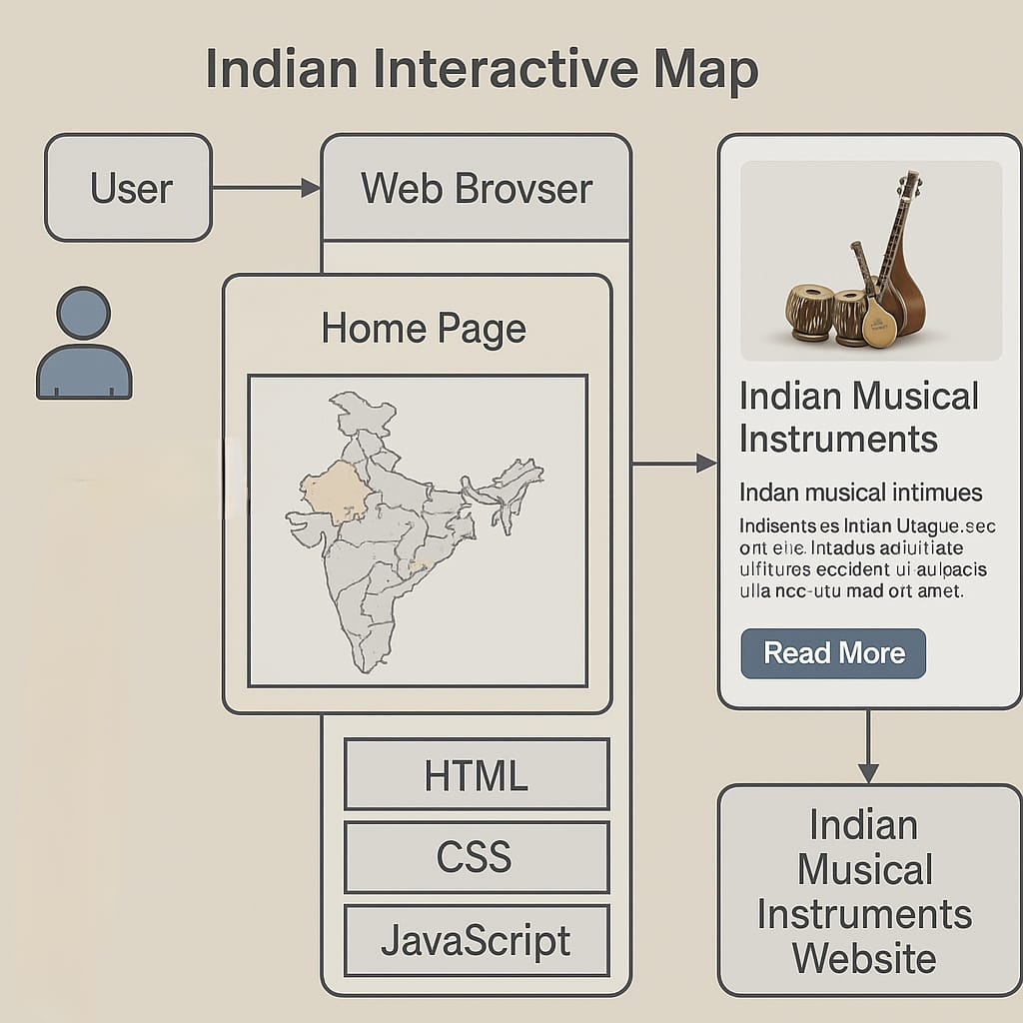

**Figure. 1.** System Architecture of NADA ANVESHA

**V. IMPLIMENTATION:**

A. USER MODULE**:**

The user plays a central role in engaging with the NADA ANVESHA platform. As the primary audience, users can freely navigate the interactive website. Upon accessing the site, users are greeted with an animated map of India where each state is clickable and responsive. Hovering over a state displays a tooltip with the name of the state and a preview of its traditional musical instruments. Clicking on the state opens a detailed page that includes high-quality images, audio samples (if available), and cultural descriptions of instruments native to that region. The interface is designed to be intuitive, visually rich, and accessible across devices, allowing users—including students, educators, and enthusiasts—to explore India’s diverse musical heritage in an immersive and educational format. Smooth animations and responsive design further enhance the user experience, ensuring that interaction with the map and content is seamless and engaging.

B. ADMIN MODULE:

The implementation of the NADA ANVESHA web platform focuses on providing an interactive and educational experience showcasing India’s traditional musical instruments. The system architecture supports two primary roles: User and Admin. General users can access the website freely and interact with a dynamic image map of India. This map is designed using HTML <map> and <area> elements, where each state is mapped with precise coordinates. On hovering or clicking a state, users are presented with tooltips or modal popups displaying detailed information about that state’s traditional instruments, including their names, images, historical background, and audio samples when available. The visual experience is enhanced through smooth animations using libraries such as Framer Motion or GSAP, which bring the cultural content to life.

The admin role is responsible for managing the platform’s content. Admin functionalities include adding, editing, or deleting information related to states and their musical instruments. This includes uploading images, text descriptions, and audio files. Admins can also modify the interactive image map by updating area coordinates and tooltip content, ensuring the platform remains accurate and engaging.

The entire frontend is built using HTML, CSS, JavaScript, and React for a responsive and animated user interface. Optionally, a backend using Firebase or Node.js can be integrated for content management and media storage. The platform supports mobile responsiveness and accessibility standards, ensuring it reaches a wide audience. Overall, NADA ANVESHA combines cultural heritage with interactive web technology to create a visually rich, user-friendly digital archive of Indian musical traditions.

**VI. A DEVLOPMENT FRAMEWORK:**

**Map Coordinates:**

The project began with selecting a digital map representation of India, where each state was assigned geographic coordinates. These coordinates were embedded within an image format to enable interactive functionalities. Using JavaScript, the system detected user interactions and displayed relevant details based on the mapped locations. This approach ensured an intuitive user experience, allowing visitors to explore the rich musical heritage of India through a visually guided journey.

.

**B. Integration of Popups:**

To enhance user interaction, popups were integrated using HTML, CSS, and JavaScript. When a user hovers over a state, a dynamic window appears, presenting an image and a brief description of the primary classical musical instrument associated with that region. This information was structured systematically to enable seamless retrieval. The hover-based approach provided users with an immediate overview of the cultural significance of various instruments, fostering curiosity and engagement**.**

**C. Frontend Styling:**

The website's visual presentation was refined using CSS to ensure a smooth and engaging user experience. Various styling elements were implemented, such as highlighting states upon hover and ensuring seamless transitions for popups. A structured layout was maintained to enhance readability and aesthetics, making the platform visually appealing. These design choices played a crucial role in reinforcing the educational objectives of the project while offering an engaging exploration of India's musical traditions.

**D. 'Read More' Navigation and Detailed Information Pages**:

A "Read More" button was incorporated within each state’s popup to provide users with an opportunity for deeper exploration. Clicking this button redirected users to a dedicated page containing a comprehensive description of the musical instrument, including historical background, playing techniques, and its significance in the respective region. High-resolution images further enriched the learning experience, enabling users to visualize the instruments in detail. This feature transformed the website into a valuable educational tool.

**VII. ALGORITHM:**

1.Start the webpage

2.Display the map of India with clickable states.

3.When a user clicks on a state

>Show the classical musical instrument of that state.

4.Display instrument name, image, and short info.

5.Allow user to click on other states to view more instruments.

6.End.

The interactive website begins by displaying a visually engaging map of India, allowing users to explore traditional musical instruments specific to each state. Upon loading, the map is fully interactive, with each state being clickable, enabling seamless navigation. When a user clicks on a state, the platform dynamically presents information about the classical musical instrument associated with that region. This includes the instrument’s name, a representative image, and a short description highlighting its history and cultural significance. Users can continue their exploration by selecting different states, with each click providing fresh insights into India's diverse musical traditions. The interface ensures smooth transitions between selections, making the experience educational and engaging. By offering easy-to-access details, this digital platform bridges geography with musical heritage, allowing visitors to immerse themselves in the rich legacy of Indian classical music. The interactive design makes it simple for users to navigate, explore, and learn, ensuring widespread accessibility for admirers, scholars, and investigators .The structured approach ensures that users can conveniently discover and appreciate India's vast and varied musical traditions while enjoying a visually rich and intuitive Navigation journey.

.

**VIII. RESULT**

The cover page of Nada Anvesha visually represents the project's core theme—exploring India's rich musical heritage. The teal background, scattered musical notes, and the "Begin Exploration" button invite users to engage with an interactive journey through India's diverse musical traditions.

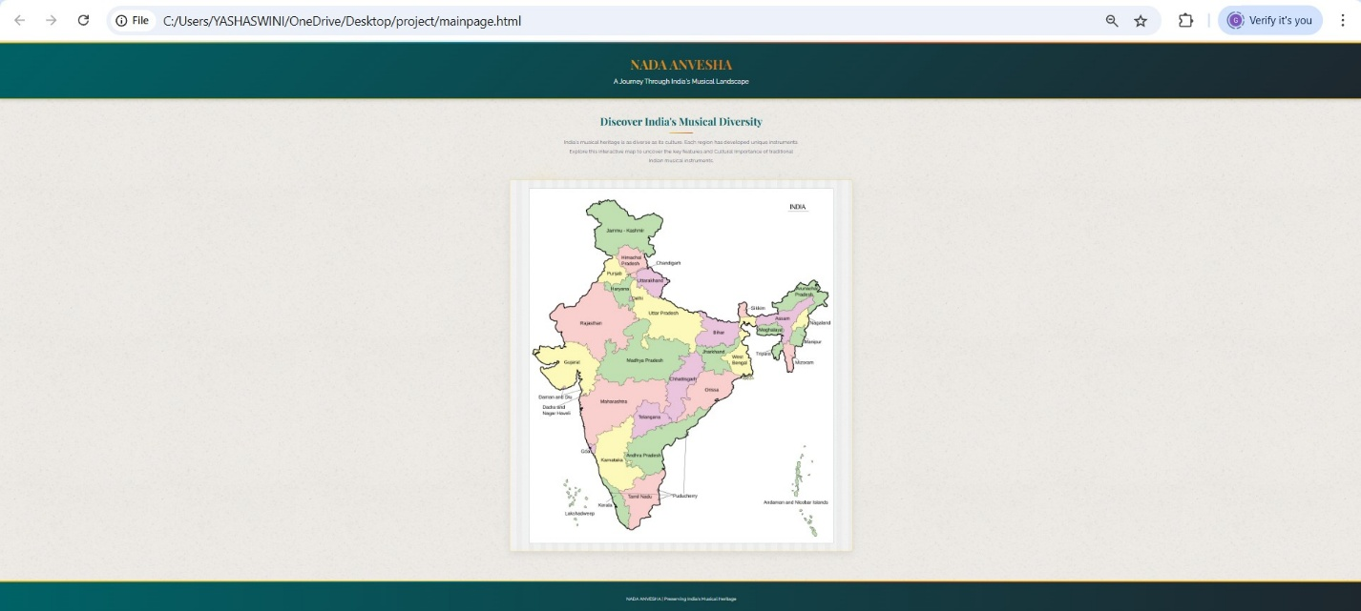

The interactive map of Nada Anvesha visually represents India's musical diversity, allowing users to explore each region's traditional instruments. With an intuitive design, the map enhances engagement by linking cultural narratives to geographic locations, enriching the experience of discovering India's musical heritage.

The interactive map feature of Nada Anvesha enhances user engagement by displaying popups when hovering over a state. These popups provide information about image and description of traditional musical instruments from each region, allowing users to explore India's diverse musical heritage seamlessly**.**

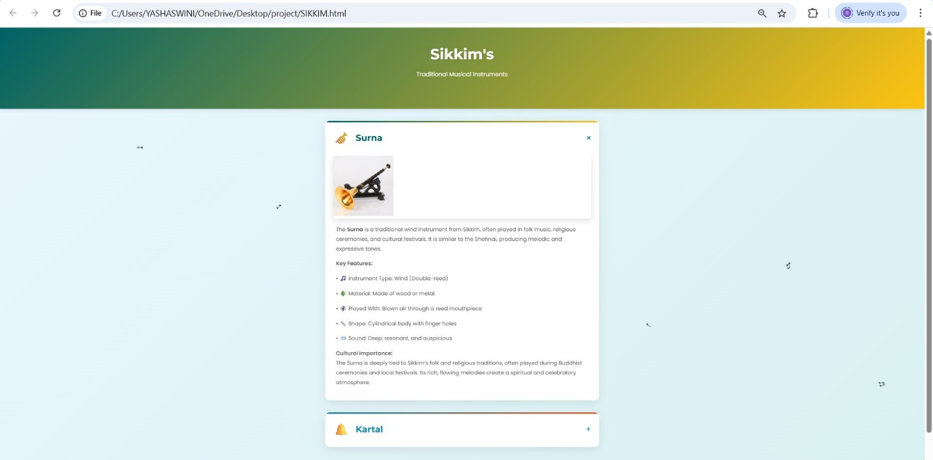

When users click "Read More" in a popup, they are redirected to a dedicated page containing a detailed description and a comprehensive list of traditional musical instruments from the selected region. This feature enriches the user experience, allowing for deeper exploration of India's musical diversity while providing historical and cultural context for each instrument.

**CONCLUSION:**

This interactive website serves as a valuable digital platform for preserving and promoting India's classical musical heritage. By combining geographical mapping with engaging multimedia content, it provides users with an intuitive way to explore traditional musical instruments across different states. The structured implementation, including hover-based popups and dedicated pages, ensures an immersive learning experience that bridges cultural storytelling with digital accessibility. As an educational tool, the platform enables schools, researchers, and music enthusiasts to integrate traditional Indian music into their studies, fostering deeper appreciation and awareness. Its user-friendly design allows seamless navigation, making musical knowledge accessible to a diverse audience. By leveraging interactivity and structured content, this project contributes to the long-term preservation of India’s rich musical traditions, ensuring that future generations can continue to engage with and celebrate the country's cultural legacy.

**References:**

1. Indian Classical Music Instruments: [Instruments used in Indian Classical Music — www.indianclassicalmusic.com](https://www.indianclassicalmusic.com/instruments)

2 Musical Instruments of India: [Musical Instruments of India | INDIAN CULTURE](https://indianculture.gov.in/musical-instruments)

1. 17 Traditional Indian Musical Instruments: [17 Traditional Indian Musical Instruments You Should Know](https://hellomusictheory.com/learn/indian-instruments/)